Clark Anderson, MD, December 3, 2014
Presentation: “Dr. Anderson’s Talk About His Career” presented June 16, 2014, transcribed November 26, 2014, by Stacey Seibert for publication on my website. The talk was accompanied by about 25 figures that I will incorporate into the text. (Slide 1)
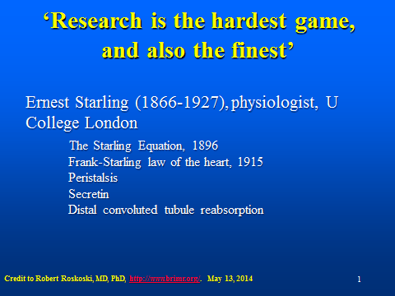
Dr. Anderson: The first slide that I show as you take your seats is presented simply to set the tone so that you know what I think is important in the world. It is a famous quotation from an illustrious 20th century biologist, Ernest Starling that says that ‘Research is the hardest game, and also the finest.’
Before I actually begin, I want to say that I was very reluctant to give a talk like this. First of all, I think that the details of my career may not be all that transferrable to you younger scientists, so I had to think hard about what commonalities you and I might share. I'll emphasize those.
My second hesitation is that it seems to me unseemly for an old geezer to get up here and reminisce about his past. This practice has always put me off and I have generally left by the back door as quickly as possible. But I've been encouraged by the reminder that many of you may take special interest in the fact that Carole, my wife, and I have sustained successfully a two-career family, both of us leading very productive careers and experiencing the joys and complexities of a family. This is an ambition and a challenge that many of you share.
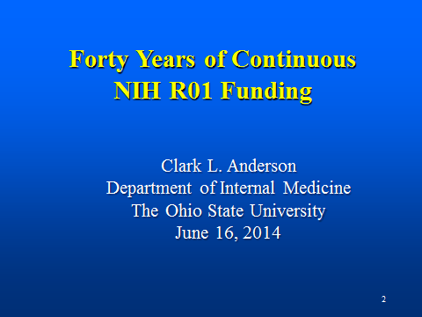
So, with these hesitations, I acceded to tell you my story (Slide 2). The reason I’m called upon today is that we've just been awarded another NIH R01 investigator-initiated research grant that, for me, makes 40 years of continuous RO1 grant funding. I'm very pleased for I think it’s a terrific record. The reason this record is important is not simply the RO1s, but for 40 years this money has given me the freedom to do exactly what I want to do. I've spent the majority of my time running a research laboratory, doing science. It's been the world's greatest job, I think. Let me start by showing you here some of the details.

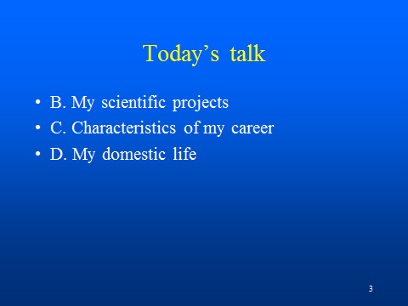
(Slide 3) I want divide my talk into three parts. I'll discuss the science, which I think is most important. I'll then pick out certain principles from my career and elaborate on them. And then I'll tell you about Carol's and my domestic life and how we worked two careers.

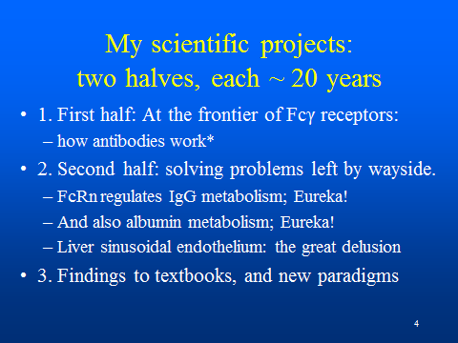
(Slide 4) As I look back upon my career, it's apparent that it can easily be divided into two halves. During the first half I was, like many of you, on a scientific frontier pushing the frontier back, along with 20 or 30 other laboratories around the world, laboratories consisting of my competitors and collaborators, all of us publishing, advancing science incrementally. I proceeded incrementally for probably 15 years until I changed my approach somewhat. I'll describe the change when I come to it.
First let me describe the first half. From the beginning as a physician interested in immune diseases I was interested in how immune complexes in tissues interact with the outer membranes of cells to trigger a variety of immune responses, the complexes either being taken up by those cells to be degraded and destroyed, or triggering these cells to perform a number of functions that ultimately lead to disposal of the offending antigen. When I started this work, the term Fc receptor had just been coined. So I was introduced to a brand new field; an important point. (Slide 5)
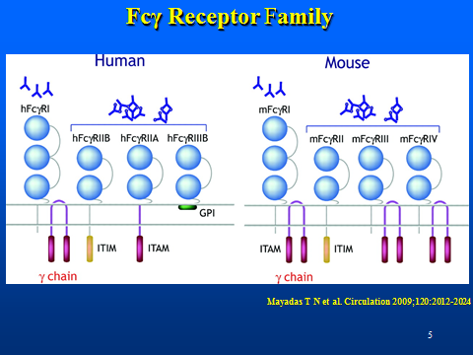
These clusters of Y-shaped molecules are immune complexes that are impinging upon a cell membrane that expresses a variety of Fc receptors. What we found over the course of the 15 years was that there are a number of integral membranes glycoproteins, Fc receptors, sitting in the plasma membrane of the cells that bind and react to the soluble immune complexes presented to them.
That was the first stage, identifying these receptors. Ultimately we found, and by we I mean I and the 20 or 30 other laboratories that I mentioned, we found a veritable zoo of Fc receptors, encoded by, I think, 8 genes in human and 5 in mouse. Whereas I started off describing THE Fc receptor on monocytes, in my first publication to the Journal of Experimental Medicine, it turned out, over the course of many years of study, that there was a large family of Fc receptors on monocytes.
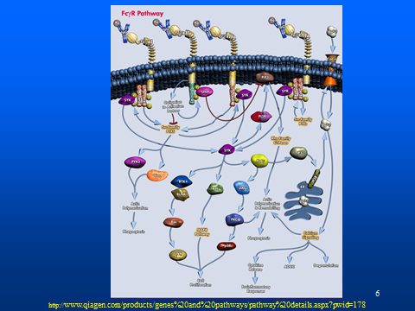
We then went on to study how these receptors, when clustered by immune complexes, signaled to the interior of the cell to manifest a number of functions that cells use to get rid of the antigens. (Slide 6)
I show you here an incredibly complex schematic from a reviewer of our field that illustrates how the signals from immune complexes impinging on the receptors at the top of the slide progress through the cell to yield the variety of functions that cells manifest, such as degradation, ADCC, inflammatory responses, phagocytosis and so on.
My field after 15 years became so incredibly complex that I wondered whether I should stick around. What should I focus on? My students were going off on many directions, directions that didn’t interest me. I began to feel that the field was hyper-mature, that we had learned everything that we could. What was the fun? What more can we do? As I look back upon these 40 years, I perceive about 20 years ago I found myself going in other directions, in directions that were tangential to my initial focus. (Slide 7)

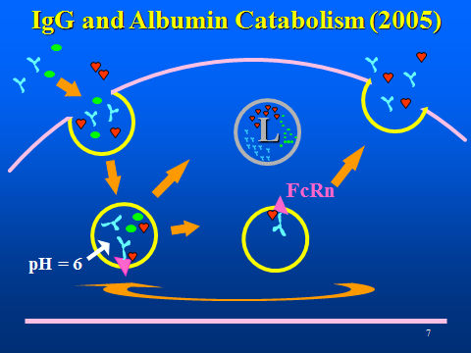
I looked for questions that had remained unanswered as the field passed over the frontier the first time, and I found fascinating areas that had not been explored, questions that I could now solve.
The first two of these explorations provoked actual Eureka moments. I had been thinking about FcRn, the receptor responsible for the transport of mother's IgG across the placenta to the fetal circulation, and I came to realize in a very abstract way that this receptor was responsible for regulating IgG metabolism. I remember distinctly that the idea of the mechanism came to me as I was listening to a seminar presented by one of my students. I jumped up and ran across the hall to my office, looked up a key paper and I hollered "Eureka! I found it!" I stripped off all my clothes and went running down the hallway shouting, "I found it!" Like who? Like… Archimedes? Right? Two thousand years ago or more. It took us about a year to do the critical experiments and publish the results. Figure 8 illustrates that FcRn, the salmon-colored triangle within acidic endosomes, binds IgG, the blue Y molecule, that had entered the cell nonspecifically, and transports it out of the cell, thus prolonging its half-life.
The second Eureka occurred when we found, or I found, actually, for it was I who did the actual signal experiment, that FcRn catabolized not only IgG but albumin as well. On a mini-sabbatical of sorts I had gone back to the bench to continue the experiments of a post-doc who had taken leave to return to Pakistan for her visa. Analyzing the protein profile of an acid eluate from an affinity column told me the answer in a flash. Eureka! I had the answer to a question that had resided in the textbooks for 80 years or more. Suddenly, it came to me one afternoon as I was doing a chromatography experiment. Albumin, shown as a red heart in Figure 8, is noted to bind to FcRn at a site distinct from but near to the binding site of IgG. Albumin is taken into the cell and transported out of the cell just as is IgG, thus prolonging its lifespan.
So, these are the sorts of delights that have been great pleasures for me. I can describe another discovery that was the result of an incredibly fruitful negative control. We realized, in a flash, that the endothelium lining the sinusoids of the liver are responsible for taking small particles out of the blood stream at a rate and to an extent greater than the macrophages of the liver, the Kupffer cells, which everybody else in the world thought was the major, if not the only, scavenger cell of the liver. We have been very forceful in trying to set the record right, believing that the biological world has suffered a delusion during the middle part of the century, concluding that the Kupffer rather than the endothelium was the major scavenger.
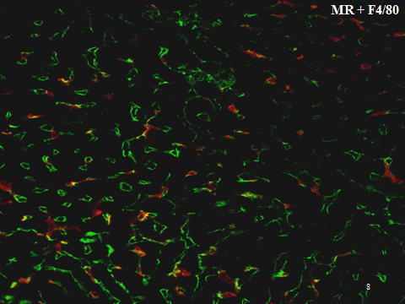
Slide 8 is an immunofluorescence photomicrograph of a slice of mouse liver showing sinusoid endothelium in green and relatively fewer Kupffer cells in red. You can see them best here in the lower left hand corner of the slide.
These findings over the 35 or 40 years have been of sufficient magnitude to alter the course of progress in these fields. They've reached the textbooks. I remember on my last visit to Colorado speaking with one of the prof`essors there that she had used one of my findings to update her lecture to the medical students about how albumin was handled by the body; that is, what the details of albumin turnover really were.
In short, what I have tried to focus on over the years are what I identify as the fundamentally important questions. Answering these questions, single-mindedly pursuing them, has yielded an impressive record that has convinced the study sections to keep giving us money now for 40 years or more.

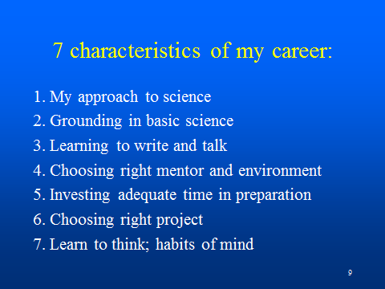
Let me turn to the principles of my career. (Slide 9)
I'll elaborate on seven principles that I've culled out and discuss them one by one.

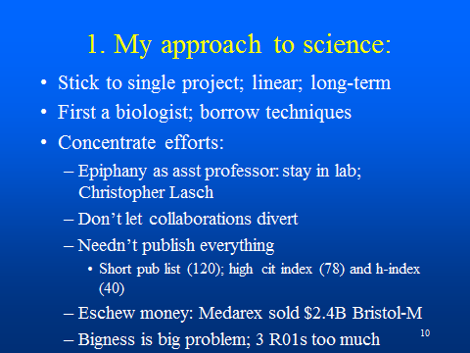
(Slide 10) First of all, as I said before, I've stuck to a single project with maybe one or two slight bifurcations. This has been very important. The linearity, the long-term concentration has been essential.
(Slide 10) Another characteristic of my success is that I consider myself fundamentally a biologist. And by that I mean I have avoided the distractions of technologies or techniques, e.g., making KO mice, developing a more refined microscope, running a flow cytometer. Someone has to be expert in these practical fields, but not I. Rather, what I did was to concentrate on the biology and borrowed and collaborated with colleagues with the technical skills to get the questions answered.
Let me describe for you my efforts at coming to terms with the demands of my career during the first couple of years of my assistant professorship. It became obvious to me that if I wanted to be a triple threat professor (teaching, research, patients), I wasn't going to thrive. Rather, I was obliged to focus, and I made the decision that research would be my primary activity. I would compete with the likes of investigators at the Rockefeller and the Whitehead Institute for NIH funds to run my laboratory, and if I failed at that ambition I would go find some other career. Of course, I had the safety net of being a clinician. So, I put my clinical skills more or less on a back burner and didn't volunteer for any lectures. I stayed in the laboratory. Close friends of mine, members of the National Academy of Sciences, supported me, saying, "Clark, don't pay any attention to departmental politics. Stay in your laboratory; lock the door." And that's what I did.
(Slide 10) At about the same time I was influenced by a professor, an historian, Christopher Lasch, at the University of Rochester, author of The Culture of Narcissism, among other books. He was an eminent historian, social critic, buddy of Jimmy Carter, hanging out at the White House, advising the President that we Americans were slack or depressed or too pleasure-seeking. What was remarkable about Christopher Lasch, I thought, was that as an eminent professor he never came to campus. It struck me like a bolt that you can have a stellar university career while nobody on campus knows anything about you except what they read in books. I took that also as a cue that I had to stay in the laboratory and do my own work.
When at mid-career I arrived here at Ohio State, I was approached by two department chairs who tried to seduce me to do their work, inviting me to tag on to their projects. Sensing their suggestions inimical, the product solely of self-interest, I resisted. I was mature enough to see that these individuals were not interested in my career at all. But I think you younger people may not see those seductions coming. And the invitation of a distinguished professor is hard to resist. But you must resist. What I did was to resist and do what I had to do by myself.
(Slide 10) I learned, actually as a post doc, that one needn't publish everything that one discovers in the laboratory. This is in contrast to what one of the former directors of our institute told us to publish everything that we do. That's not necessary. Publish only what moves the field and you'll be safer. You'll be better respected for that.
So, when I counted the publications I had in preparation for this talk, I actually had only a few: 120 including everything, even a couple of reviews and a couple of chapters. But what I was really proud of is I had a very high citation index and a very high H index, on the order those of members of the National Academy of Sciences. So, my papers have set the course for the field as manifest by their being often cited.
The other thing that's been a kind of bug-a-bear over my career has been the attraction of money. (Slide 10) And I've had to resist that attraction for it has always gotten me into trouble. The best story I can tell is when as a young professor I made two monoclonal antibodies that were important reagents to the field. Done in collaboration with a couple of professors at Dartmouth, they were the first antibodies directed against two of the three human Fc receptors. The three of us decided we had to form a biotech company to get these reagents out of my laboratory so I wasn’t overwhelmed with distributing these to everybody in the world. They too had need for commercialization, to exploit a special strategy for linking the anti-Fc receptors with anti-tumor receptors in order to make what they call bi-functional antibodies. So we formed a biotech company. And when we got together to decide who's going to be the president and the vice president, I told them that they should run the company and that I would simply remain professor and do my own research.
Initially I thought the project would fail. But it didn't. In the year 2000, one of them had a net worth of 100 million dollars, the other 50 million dollars. I, on the other hand, I had a few stock options, that's all. But I was delighted and never thought that I missed much because I had my freedom, I had my laboratory, and my laboratory was going well. I was pleased to move away from the business early in its development for I recognized that was not how I wanted to spend my life. I missed a fortune but I was happy not to participate.
Medarex was sold to Bristol Myers just a few years ago for about 2.5 billion dollars. What you should take away from this anecdote is that work like mine sometimes brings huge opportunities for fulfilling your free-market ambitions. But you need not go in that direction.
The last characteristic approach I want to mention is that I found it necessary to keep my lab at a manageable size. (Slide 10) The average number of R01 grants I managed over my career was about 1.7 per year. For a while, however, I had three RO1s at the same time; but with three R01 grants, I couldn't keep track of what was going on. That was not a good feeling. To manage successfully I needed to be smarter or stronger or blessed with more able lieutenants. Alone, I wasn't making efficient use of my money and my time and my efforts.

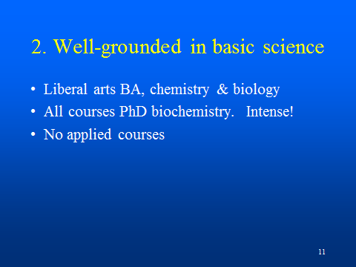
(Slide 11) Let me move to the second characteristic of my career, my grounding in basic sciences. In retrospect, I think I did everything right in preparing myself for my eventual career. What I consider especially noteworthy was that as a senior medical student I enrolled in a PhD program in biochemistry at the University of Chicago. I simply went across the street and told the dean I wanted to study biochemistry. He couldn’t have been more enthusiastic. That next year I took all of the courses necessary for the PhD program in biochemistry, which consisted of advanced organic, advanced physical chemistry, advanced biochemistry. It was an incredibly rigorous curriculum that gave me the whole background for the quantitative biology that I ultimately wanted to practice. It was extraordinarily demanding but it was worth every bit of the work. Unfortunately I was unable to proceed to do a dissertation, of which I’ll comment later.

I've never taken what I consider applied courses; e.g., courses in the genetics of cancer or the biochemistry of heart disease, or courses on specific topics like these. I recommend that if you're going to take courses, take another physical chemistry course, and you'll be in good stead with whatever biological question comes along.
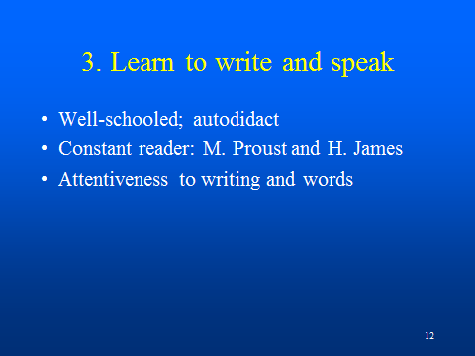
(Slide 12) Learning to write well, my third principle, got my attention early on. My grant applications were put on file at the Research Foundation as exemplary proposals when I first arrived here at OSU. Young people were invited to come and study them to learn how to write a grant application. They’ve been models of clarity; short and to the point. And I hope they've been graceful. They have been successful also. People have commented that my applications are fun to read, which I think is really remarkable when you consider the complexity of the science.
Other than studying expository composition in a serious way, the other characteristic of mine that's been critical to my writing has been that I've been a reader all my life. I read demanding stuff, Marcel Proust and Henry James…all of their great novels, over and over again, three or four times. I am so familiar with these novels that I think of the characters and the authors as personal friends of mine. That's a distinctive characteristic of mine. You’ll not find very many of us eccentrics.
Adding another dimension to my writing, I've always been attentive to words and their meanings. I collect words; make lists. I am constantly trying to move words from my reading vocabulary into my working vocabulary. I insist that my young trainees keep a list of my words that they don't understand. One of them, at last report, had accumulated 200 unknown words during her first year in my lab. I was proud to watch her whip off an email to the administrator of our building saying, "I am aghast that our sink isn't fixed yet." Her expressiveness I consider a mark of my success.
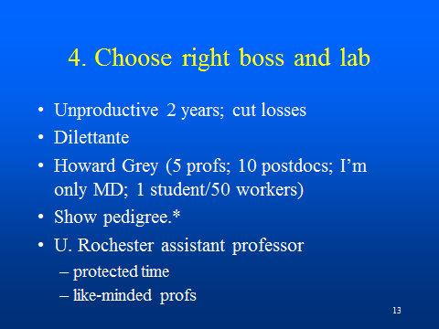
(Slide 13) The fourth element in my approach to science was choosing the right boss and lab. Early in my training I had the bad fortune of a lousy two year experience in a laboratory that wasn't going anywhere. But I was aware enough of my situation to get myself out of that lab and into the nearby laboratory of Howard Grey who was doing cutting edge work and who ultimately became a member of the National Academy. Howard accepted me, however, with great reluctance. He thought I was a dilettante. If a scientist calls you a dilettante, you had better reform, for in science that’s a derogatory word. At the time I was leading a very complex life. I was divorced and newly re-married, was responsible for three small children, was in psychoanalysis, was a musician playing in the Boulder Symphony and running my own woodwind quintet. I played squash in the city league and skied in Aspen on weekends. It's no wonder Howard thought I was a dilettante. I went to him asking initially if he would teach me some immunology. He replied that he had no interest in teaching me immunology, but if I was willing to come into his lab and work hard, he would give me a trial. So I had the great good fortune to join Howard's serious and fast-moving lab. The lab, in a research institute, was very different than here. In Howard’s suite of labs there were maybe 10 post-docs of which I was the only physician, the others being Ph.D.s. There was only a single graduate student during my entire tenure. Howard collaborated with maybe 4 or 5 other professors in close proximity.

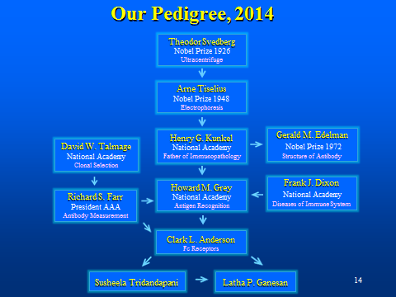
(Slide 14) I cannot begin to tell you how exciting this lab was. Instead, let me share our laboratory pedigree that I formulated a few years back. Note the scholarly distinction of all of the members of the generations. I was trained by Howard, who was a member of the National Academy. Howard was trained by Henry Kunkel, father of immunopathology, also a member of the National Academy. Kunkle post-doc'd with Arne Tiselius, the inventor of electrophoresis who won a Nobel Prize in 1948. And Tiselius was a student of Svedberg, who invented the ultracentrifuge and won a Nobel Prize for that in 1926. And you should note my uncles and great uncles here, including Gerald Edelman who won a Nobel Prize for antibody structure, the work having been done when I was in high school, I think.
I sent this pedigree to an old friend, a classmate of mine, Bob Roskoski, an MD PhD who spent his career as chair of a biochemistry department. Bob wrote back, "Nice pedigree, Clark. Let me show you mine." After his degrees Bob studied with Fritz Lipmann who won a Nobel Prize for the discovery of ATP. Lipmann post-doc'd with Hans Krebs, of cycle fame, also a Nobel laureate. The pedigree then ascended in a constant string of Nobel Prize winners through every generation until the beginning of the establishment of the Nobel Prize. Tracing further, the pedigree went back through the 19th Century where Kekule's name was entered, Kekule, the discoverer of the ring structure of benzene. And then it went back to the 18th Century, to Levosier, one of the discoverers of oxygen who was guillotined during the French Revolution.
What Bob and I think about these pedigrees is that these laboratories are special, that there is something ineffable that trickles down through the generations, a respect for truth and hard work and perseverance that lasts over the decades. Over the centuries, really.
(Slide 13) After finishing my training I joined the University of Rochester as an assistant professor. I found myself in a very congenial situation with all of my colleagues being of like mind; all investigators with their own research labs and careers. My director, especially, was protective of my time. You clinicians will be interested in my assigned duties: During the first year as an assistant professor I had no responsibilities other than my lab. During the second and third years I had I had a single departmental responsibility. And for the third and subsequent years I had two teaching responsibilities. Rochester was obviously a place where an investigator could begin. And I got moving.
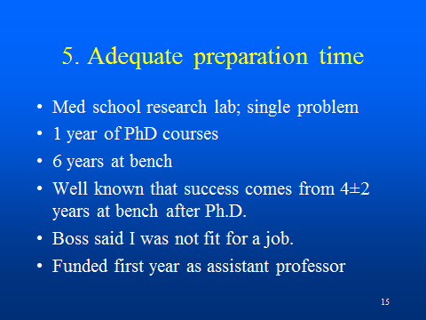
(Slide 15) If you total up the time I spent preparing for a research career, the number of years seem astonishing. I started working in a research lab as a medical student on the pathogenesis of histoplasmosis and remained with that lab for the entire four years of medical school. I took the year of PhD courses that I told you about. At the National Jewish Center I was at the bench for a total of six years. That may seem lengthy to many of you, but the first two years in the lab were not fruitful, as I said. Further, it was well known in those times that success as an independent investigator came to those individuals who were willing to spend four, plus or minus two years, at the bench after the doctoral degree. A great deal of time at the bench was necessary to learn how to do science. I don't think this fact is commonly recognized. Nobody seems to believe this. And as a result, I think a lot of young people fail. They simply aren't ready to perform independently.
Howard gave me helpful mentoring. I went to him two years shy of my ultimate departure and said, "Look, I'm finished. I've been here a long time. I'm going to go get a job." Skeptical, he asked me what I thought I could do. I said, "I want to be a scientist just like you." He told me that he didn’t think that would be possible, that I wasn’t ready to do independent research. He recommended I go elsewhere for more training, but I was captive to Denver. So, I went back and I spent another two years with him. It was good advice. At the end of those two years, I began my assistant professorship, getting both an RO1 and a career award during my very first year as an assistant professor. So the time spent as a trainee really paid off for me.
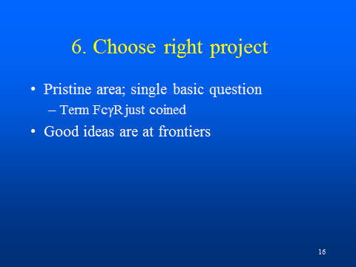
(Slide 16) It is apparent that I had the good fortune of being at the right place at the right time. My topic, Fc receptors, was brand new, had not been studied; in fact the term had just been coined. The topic was one of three that my boss, Howard, gave me saying I should choose one out of three that he thought were appropriate and important scientific questions. I chose to work on Fc receptor biology.
As I reflect back upon those events, the other two questions I believe I didn't understand. So, I took the only one I could understand, which leads me to wonder what those other two were. Were they even more exciting? Was he looking for the T-cell receptor and I lost the opportunity to go after a really fundamental 20th Century question? Maybe. I don't know.
I want to underscore for you young people that one can find good scientific questions only at the frontier of a scientific field. You can't conjure them up sitting in the library. You have to be working shoulder-to-shoulder with people at the cutting edge. In contrast, I often meet people who don’t recognize this truth. A student will come in with what he thinks is a bright idea, and the professor recommends that he go for it. I don't think that's a realistic way of choosing a topic. It's a waste of money, time and effort. So don't let anybody try to get started in that fashion.
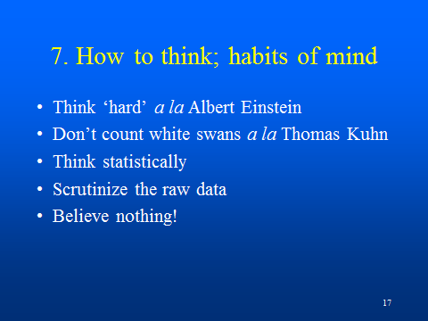
(Slide 17) Let me list my important habits of mine that I’ve accumulated over the years. I must share with you that my approach to thinking has changed since I began doing science. I taught myself to think hard. I attribute this change to reading many years ago an interview with Albert Einstein, who said when asked how he made his great discoveries that there were no secrets to his method, he simply thought long and hard about difficult questions. I pondered what he might have meant by thinking hard, and came to the conclusion that he was describing deep, prolonged, uninterrupted focus on single ideas or details. So, I learned to isolate my questions, to concentrate, to avoid all distractions.
On Sunday morning, driving 40 miles on the interstate to race my sailboat at the finger lakes yacht club, alone in the car, I would turn off the radio and focus on scientific problems, designing experiments. If I had a great idea, I would pull off the road and write the idea in my notebook. Thus, thinking hard about problems has been a critical characteristic of mine.
Another self-taught approach: Thomas Kuhn, a physicist philosopher of the mid part of the last century, has in recent years been very influential to me in that he taught me how to test hypotheses. A laboratory presents the investigator with thousands of questions. How does one choose the good questions? Which experiments do you want to do? Kuhn taught me to select only those experiments that were capable of refuting my hypotheses. If you follow that rule, then you don't have many experiments to do. You spend most of your time thinking, and you do only the important experiments.
Applying statistics: I think all along I've thought statistically and I've encouraged my young people to take extra courses in statistics. We've consulted with statisticians, we've collaborated with statisticians. It's been an essential part of our progress.
Study the data. There's no substitute for looking at the gel or the numbers or the pattern or the profile that represents raw data. You’ve got to do that no matter how many people you supervise. If you don't, you’re going to miss very important answers. That's a very basic precept.
And the other precept is the skeptic’s mantra, believe nothing. Being skeptical has actually become detrimental to my getting along in the world because I no longer believe what anybody says. I don't read papers; I read only tables and figures. If I'm interested in what the author concluded about the data in these tables and figures, then I'll read the discussion. But stick to the tables and figures and keep a skeptical eye that the data may have been collected them erroneously.
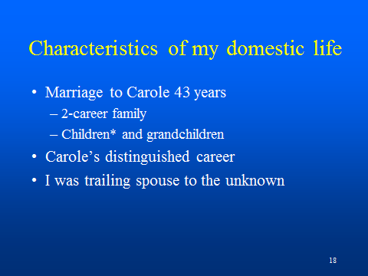
(Slide 18) Carole and I have put together two careers and a family in a reasonably successful way that is worth describing for you all. I'll tell about Carole in a minute, but first let me show you a picture of the three daughters.
(Slide 19) The girls all went to very expensive private colleges for their education; the best we could buy. One of them got a PhD, one a master’s degree, and another has changed careers. They all have families and there are a bunch of grandchildren now. So, in that respect, I think Carole and I have done pretty well.
I met Carole when she was a psychiatric nurse in Colorado. She was a faculty member and she had a private practice of psychotherapy, a practice that she sustained throughout her entire career. Even as a dean she continued to see patients.
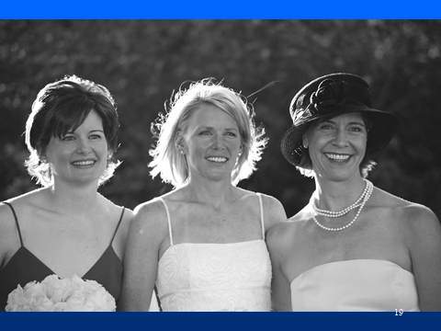
(Slide 18) At about the time I met Carole she was getting her PhD in sociology, which she considered a logical next step beyond psychiatric nursing, given her abiding interest over the years in criminals and in deviance. Her friends thought that her interest in deviance explained her attraction to me. She got her PhD at about the time we left Colorado for my first job at the University of Rochester. After being associate dean of the nursing school at Rochester for several years she ultimately got the job as the dean of the College of Nursing here at Ohio State. I followed her to OSU as the trailing spouse, striking out into the unknown, for I had never heard of OSU.
Carole was dean of the College of Nursing for 15 years. She was so expert that they made her dean of the Graduate School for a couple of years. And then, realizing that she was capable of solving almost any higher education problem, they made her dean of dentistry for the last five years of her career. Retired as the doyenne of administrators of higher education, she is now living a life of leisure.
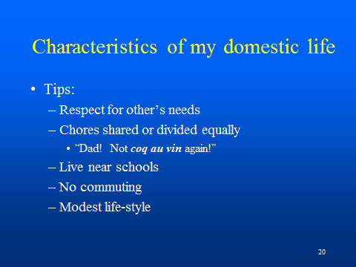
The tips for you that I would glean from my domestic history is that we both totally supported the other's career.
(Slide 20) It should be noted that she followed me to Rochester for my first job; and I followed her to Ohio State for her first big job. We've both had genuinely heartfelt respect for the other's professional success.
In running the household we have shared virtually everything, dividing up all of the duties. One really unique characteristic of our approach was that I cooked and shopped on even-numbered months, and she cooked and shopped on odd-numbered months. My favorite cookbook was Pierre Franey and Craig Claiborne's The 60-Minute Gourmet. The kids were subjected to the dishes so often that they began to complain. For example, every Sunday night was a cheese soufflé. On Saturday night, like all Americans, we ate hamburger, but our hamburger during my month as cook was hamburger au poivre. We always lived near the schools so the kids could take the bus or walk, a detail that we felt very important so there would be no schlepping them everywhere. We did very little commuting. Here in Columbus we live just five minutes down the street. Both of us walked to work and I biked to work up until a year or so ago. I would describe our lifestyle as being relatively simple. We haven't had the yearning for big trips or big toys or big entertainments. We've lived, I think, a fairly modest life.
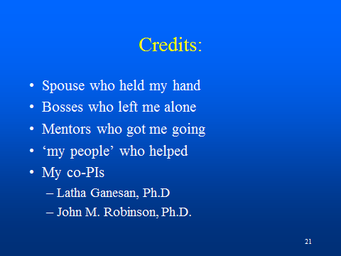
(Slide 21) I have to give credit to lots of other people, of course. Especially I want to acknowledge Latha Ganesan and John Robinson, my co-principal investigators on this last NIH RO1 grant.
(Slide 22) In closing, I will remind you of the famous quotation of Kierkegaard, 19th Century Danish philosopher: "One of the great tragedies of life is that it can only be understood from the end, whereas life must be lived from the beginning." From the end of my career I can tell you with some ease my understanding of my own scientific life. But, alas, you must face your own challenges alone, making your decisions as you go.
With that comment, I will ask you if you have any special questions that I could answer. (Slide 23)
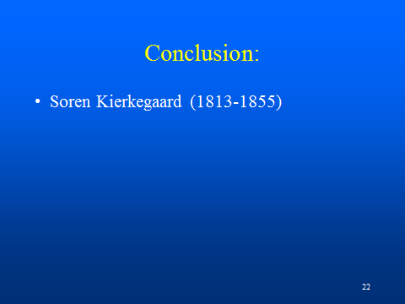

[applause]

QUESTION: One thing that you talked about that I think young scientists struggle with, you talked about the two phases of your career. And sometimes departing a little bit from your trajectory can be risky, but in your case was obviously very productive. How do you make that decision? How do you do the risk-benefit analysis of branching out to another area and leaving where you were? And how did you go about that?

Dr. Anderson: Yes. We've caught a fair amount of flack in changing direction. I can remember when I first started studying FcRn, which represented, as I said, at a fork in our pathway; and then especially when I started moving into details of the liver sinusoidal endothelium. The liver experts said that we didn’t know anything about the liver. How arrogant of you to come asking for money to study the liver when you have no papers, no data, no nothing. That's true. We tried multiple times. We persevered, for we knew we were right. We argued as cogently and as thoroughly as we could, and finally they gave us the money.
Sometimes the money came too late. I remember one grant on albumin metabolism. By the time I got the grant, I had already answered all of the important questions. So, I used the money to go in another direction. By that time I had a pretty good track record. Reviewers were beginning to realize that I could do what I said I could do. It is risky to fork off the path. But if you're not excited about the old question, it’s even more risky to stick with it.

QUESTION: I'd like to know your favorite thing about Ohio State and one thing, that if you could, you would change?

Dr. Anderson: Oh. I was hoping that nobody would ask that.

[laughter]

Dr. Anderson: I told you that I did not come here willingly. I came here because my wife's career demanded that. And when I got here I was shown a basement laboratory with no facilities. I discovered immediately that half of the lighting in my ceiling was out. And I went around campus and found that every other light bulb in the entire campus had been removed. In fact, even over the President’s desk, the fixtures had only half of the lighting installed. I thought that I had come to a very sleepy place, to a place that hadn’t awakened from the oil embargo of the 70s, to a place that for 15 years had been existing on half of the wattage necessary for reading, according to standards that had been set by the federal government using data gathered here at this very university.
I was given almost half of my salary, so that was a good thing about Ohio State. And I was left absolutely alone; I could do whatever I wanted; no demands were made upon me. So, money and freedom were my favorite things about Ohio State; those are two huge benefits, for which I am eternally grateful. What else could a young scientist need?

Who else has any questions?

Question: You never did tell me ever how you got interested in science. You were a medical doctor and then you decided to go off into science. Why did you do that?

Dr. Anderson: I was interested in bugs as a little boy, as probably all of you were. I lived in Japan for a while as a child, and I had a collection of the remarkable horned beetles, about as long as your index finger, that were prevalent in the Japanese countryside; I had a whole collection of 20 or 30 of them pinned to my board. So early on, yes, I was interested in science; I majored in science in college. Actually, however, I went off to college as a pre-dental student, having been influenced by family members who were dentists. I had never met a physician, except for my grandfather.
My grandfather was my hero. In immigrant from Sweden, he started his working life at the age of 13 driving a mule team for the railroad that was passing across Iowa in the 1880s. He then became a barber, and then a dentist. His fellow surgeons in this little Iowa town where he practiced encouraged him to be their anesthesiologist, for he knew well the anatomy of the head and neck. Believing he needed to know more about medicine, he went back and got his medical degree. Upon his retirement he again went back to the university and got a bachelor’s degree in archeology. So, from mule team to barber to dentist to physician to archaeologist. He was my model. I loved that.
The last story reminds me that when as a college boy I changed to a pre-medicine curriculum, I didn't really think of myself as being pre-med; rather, I thought of myself as being a human biologist. With different advice I could have gone in the PhD direction rather than toward an MD degree. I went to the University of Chicago, which was a great blessing, a wonderful experience. University of Chicago is the greatest university in the world, if you don't know about that already. It was absolutely enthralling from the very beginning to the very end. I went back there last week to celebrate my 50th anniversary graduation from medical school, and was able to sit around with 40 other old geezers to reminisce about the old times.

